# Text recognition

AI Builder Text recognition is a prebuilt AI model that extracts lines of text from documents and images. AI models usually require that you provide samples of data to train before you are able to perform predictions. You can pretrain prebuilt models by using a set of samples that are provided by Microsoft so they are instantly ready for use in predictions.

## **Create an application in Power Apps**

To create an application in Power Apps, follow these steps:

1. Select **Create** in the **Power Apps** menu.
2. Select **Canvas app from blank**.
3. Name the canvas app **Contoso Text Recognizer**.
4. Select **Phone**.
5. Select **Create**.

Your next task is to give users the ability to automatically retrieve the text lines that are visible in the image.

1. From **Insert > AI Builder**, select **Text recognizer (preview)**. This control allows you to take or upload a picture and automatically recognizes the container identifier.

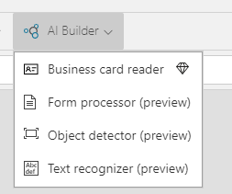

1. Resize the control to fit in the screen.

## **Provide feedback about recognized text**

To provide feedback to the user about recognized text, follow these steps:

1. Select **Insert a new label**.
2. Beneath the **Text Recognizer** component, change the **Text** property to **Selected text:**
3. Beside the **Insert a text** field, change the **Default** property to **TextRecognizer1.Selected.Text**. This property will display the text that was manually selected by the user from the list of texts that were recognized by AI Builder.

## Retrieve the list of all text lines and display it to the user

To retrieve the list of all text lines that are present in the image and then display it to the user, you can insert a data table and then change the **Items** property to **TextRecognizer1.Results**. This change will bind the list of recognized text lines to the data table.

## **Add a field to be displayed in the data table**

On the right pane, select **Edit Fields** and enter the word **text**, which contains the list of recognized text lines.

To make the field more meaningful, change the **FieldDisplayName** property of **text_column1** to **All recognized texts:**, as shown in the following image.

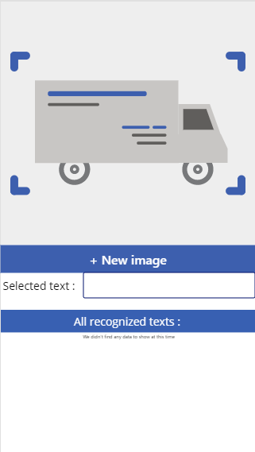

## Test that the application works properly

Select the **run** button on the right side of the screen.

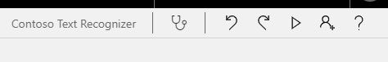

To analyze an image, select **+ New image** and then select an image from your disk. You can also take a picture with your mobile device.

AI Builder Text recognition will now process the image and will display the recognized text in blue bounding boxes.